# Objective 9 Splunk!

Blue team professionals working in Security Operations Centers (SOCs) or incident response need software to collect log files from many different systems and display them in a useable, searchable format. Splunk is one product that fulfills this Security Information and Event Monitoring (SIEM) function. First, we to visit Fitzy Shortstack in the lobby of Santa’s castle.

|  |  |
| --- | --- |
|  |  |

## Terminal Yara Analysis

YARA is a system of rules for recording information about malware so it can be distributed to ITSec people.

|  |  |
| --- | --- |
|  |  |

In this terminal you will alter an executable binary file so that it passes YARA rules and measures the sweetness of North Pole candy. The terminal does not have a hex editor available, so you must edit the file with vim and xxd.

### Step 1 question: Does it run?

Will ./the_critical_elf_app run?

### Step 1 answer

No. When you run the application, it fails yara_rule_135.

### Step 2 question: Find the problem rule

The applications more and less both allow you to search for a term. Just enter ‘/’ followed by the searchterm. What is the rule triggering on?

### Step 2 answer

The find feature of less (/searchterm) helps us locate rule 135.

We must remove or alter the string “candycane” to pass this rule.

### Step 3 question: Edit a binary with vim? Really?

After much searching, I found these links which explain how to use vim and xxd together to edit binary files.  
<https://askubuntu.com/questions/786658/how-do-i-edit-the-binary-or-hexadecimal-data-of-a-file-in-ubuntu#:~:text=xxd%20is%20a%20linux%20command,b%20and%20then%20press%20ENTER%20.&text=Press%20ESC%20and%20then%20i,which%20allows%20you%20to%20edit.>  
<https://transang.me/edit-binary-file-with-vim-and-the-xxd-command/>  
<https://vi.stackexchange.com/questions/343/how-to-edit-binary-files-with-vim>

### Step 3 answer

Open the_critical_app in vim.

Then enter the vim command :%! xxd. This tells vim to run the xxd command against the text so we can read and edit it.

We can edit this.

Pressing “i” puts us in insert mode.

Then change the string candycane. I chose to change 6e (last n in candycane) to 6d. Notice that the hex changed, but the ASCII translation in the right column did not change.

Now, change the text back to binary. Hit escape to exit insert mode, then scroll to the very top of the text.

Use :%! xxd -r to tell vi/xxd to put it back in binary.

Enter :wq to write the changes and quit vm.

### Step 4 question: Next?

Try to run the binary again. If it fails, fix it (again.)

### Step 4 answer

Run the binary and fail the next rule.

This time the rule is looking for hex strings, either 6c 6962 632e 736f 2e36 or 726f 6772 616d 2121.

Our friend CyberChef from GCHQ can help.

|  |  |
| --- | --- |
|  |  |

We had best change the second string, as the first may cause the libc.so.6 not to load. Use the same procedure as before. I like to pick on “m”, so I changed 6d to 6e.

### Step 5 question: Again?

This time the binary hits a more complicated rule. There’s an easy way to fix it, and a hard way.

### Step 5 answer

When we run the app again, we hit yet another YARA rule.

This one is more complicated.

The condition is uint32(1) == 0x02464c45 AND filesize < 50KB AND 10 of them

Trying to find 10 strings that will not break the app by changing them seems like a lot of work. The uint32 test looks for the 32 bits, starting with the second byte in the file. It is little-endian, so will be backwards.

It is looking for the magic bytes of an ELF executable; we cannot change that. So, make the file larger than 50 kB.

### Step 6 question: Make it bigger?

The not quite correctly named Linux app, truncate, can also add padding to files.  
<https://linuxhint.com/truncate-command-in-linux/>  
<https://superuser.com/questions/1535572/can-i-create-an-image-with-a-specific-size-in-bytes/1536157#1536157>

### Step 6 answer

Use truncate to increase the file size to just over 50 kB.

Solved.

## Hints after solving Yara Analysis

Fitzy has assistance for us.

|  |  |
| --- | --- |
|  |  |

## Objective 9 Splunk!

Clicking the terminal next to Angel Candysalt in the castle great room takes you to a Splunk interface. The sample Splunk searches were very helpful.

### Task 1 question

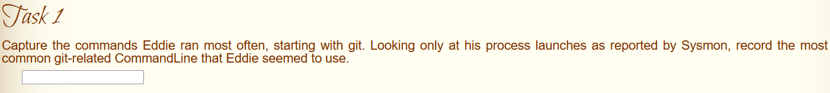

### Task 1 answer

I used sample search 4 and found the most used git command was git status.

### Task 2 question

### Task 2 answer

Use search 4 again, and add a regex to search for “origin” .

The answer was [git@github.com:elfnp3/partnerapi.git](mailto:git@github.com:elfnp3/partnerapi.git)

### Task 3 question

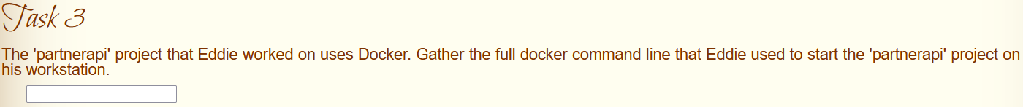

### Task 3 answer

Again, sample search 4 helps.

docker compose up

### Task 4 question

Note. Task 4 was modified in early January because the elfnp3 github entry was deleted.

### Task 4 answer

Sample search 6 is set up for webhook events.

Because of the change, they accept either <https://github.com/snoopysecurity/dvws-node> or dvws-node.

### Task 5 question



### Task 5 answer

I modified search 4 again to add a regex for “npm”.

holiday-utils-js is the answer they are looking for.

### Task 6 question

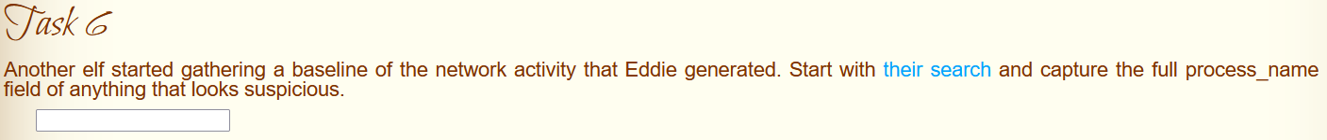

### Task 6 answer

That search leads you to two IP addresses. The second is the one that had the alerts.

Drilling into one of the events took me here.

<snip>

The problem process was /usr/bin/nc.openbsd.

### Task 7 question

### Task 7 answer

Starting with the query from Task 6, find the process_id, 6791. Go back to sample search 2 and modify it to look for process_id=6971.

Next, look for the ParentProcessID so we can look for other processes that it launched.

The parent was 6788, so look for other processes that have the same parent.  
index=main sourcetype=journald source=Journald:Microsoft-Windows-Sysmon/Operational EventCode=1 ParentProcessId=6788

One of the children of 6788 launched a cat command to steal Eddie’s credentials.

There were 6 files.

### Task 8 question

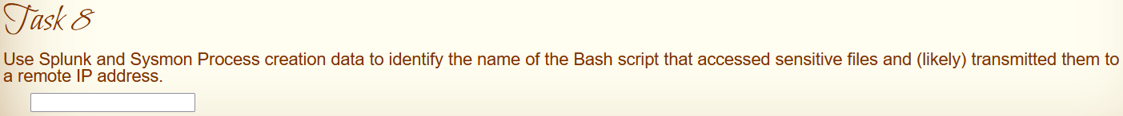

### Task 8 answer

Keep walking up the parent tree, starting with process_id 6788.

The command line for 6788 was /bin/bash. No help there, find the parent for 6788.

The parent of 6788 was 6784, what did it do?

The command line was /bin/bash, so we keep looking. The parent of 6784 was 6783.

The new parent is 6783, so search for it.

Aha! It was /bin/bash/preinstall.sh, which is part of the package Santa asked Eddy to load. Oops.

